caBIG

Health Insurance Portability and Accountability Act (HIPAA) Compliance Test Plan

Author : Jeff Pierce
Ekagra Software Technologies, Ltd
Team : caBIG QA
Subcontract: 29XS223STO1

Document Change History
Version Number | Date | Contributor | Description
V0.1 | 6/23/2010 | Jeff Pierce | Initial outline/draft


Updated September 16, 2010
Table of Contents

1 Introduction 2
1.1 Test Strategy and Approach 2
1.1.1 Process 2
1.1.1.1 Assessment and Analysis 2
1.1.1.2 Remediation 3
1.2 Scope and Objectives 3
1.2.1 Objectives 3
1.2.2 In Scope 3
1.2.3 Out of Scope 3
1.3 Assumptions 3
1.4 Constraints 4
1.5 Relationship to Other Documents/Plans 4
2 Test Specifications 4
2.1 Administrative Safeguards – Rules and Tests 5
2.2 Physical Safeguards – Rules and Tests 7
2.3 Technical Safeguards – Rules and Tests 9
3 Test workplan and Schedule 10
4 Test Completion Criteria 10
5 Resources 10
5.1 Team Resources and LOE 10
5.2 Roles and Responsibilities 10
5.2.1 Development (ESD) DSL/Stream 10
5.2.2 QA DSL/Stream 11
5.2.3 Architecture DSL/Stream 11
5.2.4 Analysis DSL/Stream 11
5.2.5 Continuous Delivery Operations (CDO) Stream 11
5.3 Test Tools and Processes 11
5.3.1 Pre-requisites 11
5.3.1.1 Analysis 11
5.3.1.2 Architecture 12
5.3.2 Test Case Creation/Execution Process 12
5.3.2.1 Review Requirements 12
5.3.2.2 Review the PIM 12
5.3.2.3 Review JPEG Images of RMIM Diagrams 12
5.3.2.4 Check ISO 21090 HealthCare Datatypes 12
5.3.2.5 Check the Terminology Worksheet for Data Values 12
5.3.2.6 Web Services Definition Language (WSDL) File 13
5.3.2.7 Document Test Case Scenarios 13
5.3.2.8 Create Test XML Message Payloads (SoapUI Scripts) 14
5.3.2.9 Execute Test and Validate Results 15
5.3.2.10 Record Test Result and document defects as needed 15
5.3.3 Automated Testing 15
5.3.4 Requirements Traceability 15
5.3.5 Metrics and Defect Tracking 16

Introduction
This Test Plan document describes the test objectives, scope, strategy and approach, methods, tools and resources, and expected outcomes used to plan, organize, execute and manage the HIPAA compliance Quality Assurance activities of the caBIG project.

The Health Insurance Portability Administration Act of 1996 (HIPAA) (Public Law 104-191; 104th Congress) was enacted “to amend the Internal Revenue Code of 1986 to improve portability and continuity of health insurance coverage in the group and individual markets, to combat waste, fraud, and abuse in health insurance and health care delivery, to promote the use of medical savings accounts, to improve access to long-term care services and coverage, to simplify the administration of health insurance, and for other purposes.”()

Its purpose is further elaborated in Title II, the Administrative Simplification (AS) provisions, to “improve the Medicare program under title XVIII of the Social Security Act, the Medicaid program under title XIX of such Act, and the efficiency and effectiveness of the health care system, by encouraging the development of a health information system through the establishment of standards and requirements for the electronic transmission of certain health information”()

Title II of HIPAA requires the Department of Health and Human Services (HHS) to draft rules aimed at increasing the efficiency and effectiveness of the health care system by creating standards and rules for the use and dissemination of health care information.

As caBIG is developing open source sSOA service specifications and service implementations for ambulatory oncology specific Electronic Health Record (EHR) systems, the law and the HHS rules and provisions are applicable to the project deliverables and implementations and caBIG deliverables must be validated to ensure compliance.

Test Strategy and Approach

HIPAA compliance testing refers to the set of QA activities to assure caBIG deliverables meets compliance requirements.

Process

Assessment and Analysis
From a process perspective, at the highest level, the caBIG project must undertake an effort to complete a high level assessment, to identify impacted systems and processes. The results of this initial assessment will drive subsequent analysis efforts including detailed gap analysis of affected systems and processes:
- Code analysis
- Transaction analysis
- Operational analysis
- Data Dictionary & Data Mapping
- Security Design
- Privacy Analysis

It is from the aforementioned assessment and analysis activities that the Remediation Approach, plan and schedule.

It is assumed at this time that the analysis team will undertake and lead the assessment and analysis process. QA specific activities are outlined as part of the Remediation activities related to system implementation and testing.

Remediation
Remediation steps are outlined below. Specific steps would be defined by the assessment and analysis, but at a high level the following steps need to be accomplished:
- Remediation system design
- Procedural changes design
- Coding and Testing
- Implementation
- Communication and Training

The expectation is that requirements, developed by A&A, would be documented as part of the specification set, and QA would validate them in the remediation test phase through test cases developed from the requirements and use cases specific to HIPAA compliance. Test cases will be clearly documented so that they can be executed either manually or automatically.

Scope and Objectives

Objectives

In Scope
The HIPAA Compliance Test scope includes the following:
- System testing to ensure system compliance with technical requirements defined by HIPAA standards, as documented in requirements from assessment and analysis done by A&A teams.

Out of Scope
The following are considered out of scope for caBIG HIPAA Compliance Testing:
- Definition and administration of Policy and Procedures

Assumptions

- Assessment and Analysis would be completed by A&A teams
- QA is not responsible for creation and adoption of organizational policies related to HIPAA compliance
- Requirements baseline has been established for a given cycle (sprint/iteration/release).
- Architecture baseline has been established for a given cycle (sprint/iteration/release).
- For software to pass Test Readiness Review (TRR) milestone, the Developer team has completed unit, system and integration testing and met the entire baseline Requirements for that cycle.
- Test scripts are developed, reviewed and approved.
- ISO 21090 Data type - This project has determined that the ISO 21090 NCI localization to be used is leveraged from previous NCI projects, which have a high level of testing and are now in production.

Constraints
- QA team must work from a baseline set of artifacts.
- Test scripts must be approved by Test Lead prior test execution

Relationship to Other Documents/Plans
HIPAA compliance testing is one of several components to the overall compliance testing necessary for verification of the caBIG system as described in the caBIG Master QA Plan.

This plan references the following other documents:
- Master_QA_Plan – caBIG – defines the complete test strategy and all associated sub-plans
- HIPAA Compliance Test Plan – (this document) described the test plan for HIPAA compliance specific QA work
- HIPAA Compliance Test Cases – Will contain the documented test cases. Note: This may be contained in HP Quality Center, test case management tool repository
- HIPAA Compliance Test Report – The test execution report and results.
- Defect Documentation – defects are logged in HP QC and via Jira Bridge are synchronized with equivalent entries in JIRA for individual discipline management and closure. Defect reports will be available online or in test execution report
- Requirements – the artifacts from A&A that document requirements used as a basis for developed test cases.
- Requirements Traceability Matrix – a report demonstrating test case traceability to requirements
- Platform Independent Model (PIM) – Service specifications documentation created by Architecture team used as a basis for test case development.
- Metrics Outline for caBIG – describes the metrics planned to be tracked for caBIG and relevant sources

The caBIG Master QA Plan describes testing terminology definitions and overall scope and approach to Quality Assurance on the project.

Test Specifications

As mentioned above, HIPAA requires that HHS draft standards and rules for the use and dissemination of health care information. The HHS Electronic Code of Federal Regulations, Title 45, Subtitle A, Subchapter C describes these rules in Part 164 – Security and Privacy, specifically in Subpart C--Security Standards for the Protection of Electronic Health Information. The applicable rules are broken down into 3 main areas:

- §164.308 Administrative safeguards.
- §164.310 Physical safeguards
- §164.312 Technical safeguards

Tests must be developed as described to ensure that caBIG is compliance with all of the applicable rules defined in these sub-parts as follows:

Administrative Safeguards – Rules and Tests

Rule | Description | Test
164.308(a)(1)(i) | (1)(i) STANDARD: Security management process. Implement policies and procedures to prevent, detect, contain, and correct security violations.
164.308(a)(1)(ii)(A) | (A) Risk analysis (Required). Conduct an accurate and thorough assessment of the potential risks and vulnerabilities to the confidentiality, integrity, and availability of electronic protected health information held by the covered entity. | Has a Risk Analysis been completed IAW NIST Guidelines? (R)
164.308(a)(1)(ii)(B) | (B) Risk management (Required). Implement security measures sufficient to reduce risks and vulnerabilities to a reasonable and appropriate level to comply with §164.306(a). | Has the Risk Management process been completed IAW NIST Guidelines? (R)
164.308(a)(1)(ii)(C) | (C) Sanction policy (Required). Apply appropriate sanctions against workforce members who fail to comply with the security policies and procedures of the covered entity. | Do you have formal sanctions against employees who fail to comply with security policies and procedures? (R)
164.308(a)(1)(ii)(D) | (D) Information system activity review (Required). Implement procedures to regularly review records of information system activity, such as audit logs, access reports, and security incident tracking reports. | Have you implemented procedures to regularly review records of IS activity such as audit logs, access reports, and security incident tracking? (R)
164.308(a)(2) | (2) STANDARD: Assigned security responsibility. Identify the security official who is responsible for the development and implementation of the policies and procedures required by this subpart for the entity.
164.308(a)(3)(i) | (3)(i) STANDARD: Workforce security. Implement policies and procedures to ensure that all members of its workforce have appropriate access to electronic protected health information, as provided under paragraph (a)(4) of this section, and to prevent those workforce members who do not have access under paragraph (a)(4) of this section from obtaining access to electronic protected health information.
164.308(a)(3)(ii)(A) | (A) Authorization and/or supervision (Addressable). Implement procedures for the authorization and/or supervision of workforce members who work with electronic protected health information or in locations where it might be accessed. | Have you implemented procedures for the authorization and/or supervision of employees who work with EPHI or in locations where it might be accessed? (A)
164.308(a)(3)(ii)(B) | (B) Workforce clearance procedure (Addressable). Implement procedures to determine that the access of a workforce member to electronic protected health information is appropriate. | Have you implemented procedures to determine that the Access of an employee to EPHI is appropriate? (A)
164.308(a)(3)(ii)(C) | (C) Termination procedures (Addressable). Implement procedures for terminating access to electronic protected health information when the employment of a workforce member ends or as required by determinations made as specified in paragraph (a)(3)(ii)(B) of this section. | Have you implemented procedures for terminating access to EPHI when an employee leaves you organization or as required by paragraph (a)(3)(ii)(B) of this section? (A)
164.308(a)(4)(i) | (4)(i) STANDARD: Information access management. Implement policies and procedures for authorizing access to electronic protected health information that are consistent with the applicable requirements of subpart E of this part.
164.308(a)(4)(ii)(A) | (A) Isolating health care clearinghouse functions (Required). If a health care clearinghouse is part of a larger organization, the clearinghouse must implement policies and procedures that protect the electronic protected health information of the clearinghouse from unauthorized access by the larger organization. | If you are a clearinghouse that is part of a larger organization, have you implemented policies and procedures to protect EPHI from the larger organization? (A)
164.308(a)(4)(ii)(B) | (B) Access authorization (Addressable). Implement policies and procedures for granting access to electronic protected health information, for example, through access to a workstation, transaction, program, process, or other mechanism. | Have you implemented policies and procedures for granting access to EPHI, for example, through access to a workstation, transaction, program, or process? (A)
164.308(a)(4)(ii)(C) | (C) Access establishment and modification (Addressable). Implement policies and procedures that, based upon the entity's access authorization policies, establish, document, review, and modify a user's right of access to a workstation, transaction, program, or process. | Have you implemented policies and procedures that are based upon your access authorization policies, established, document, review, and modify a user’s right of access to a workstation, transaction, program, or process? (A)
164.308(a)(5)(i) | (5)(i) STANDARD: Security awareness and training. Implement a security awareness and training program for all members of its workforce (including management).
164.308(a)(5)(ii)(A) | (A) Security reminders (Addressable). Periodic security updates. | Do you provide periodic information security reminders? (A)
164.308(a)(5)(ii)(B) | (B) Protection from malicious software (Addressable). Procedures for guarding against, detecting, and reporting malicious software. | Do you have policies and procedures for guarding against, detecting, and reporting malicious software? (A)
164.308(a)(5)(ii)(C) | (C) Log-in monitoring (Addressable). Procedures for monitoring log-in attempts and reporting discrepancies. | Do you have procedures for monitoring login attempts and reporting discrepancies? (A)
164.308(a)(5)(ii)(D) | (D) Password management (Addressable). Procedures for creating, changing, and safeguarding passwords. | Do you have procedures for creating, changing, and safeguarding passwords? (A)
164.308(a)(6)(i) | (6)(i) STANDARD: Security incident procedures. Implement policies and procedures to address security incidents.
164.308(a)(6)(ii) | (ii) Implementation specification: Response and Reporting (Required). Identify and respond to suspected or known security incidents; mitigate, to the extent practicable, harmful effects of security incidents that are known to the covered entity; and document security incidents and their outcomes. | Do you have procedures to identify and respond to suspected or know security incidents; mitigate to the extent practicable, harmful effects of known security incidents; and document incidents and their outcomes? (R)
164.308(a)(7)(i) | (7)(i) STANDARD: Contingency plan. Establish (and implement as needed) policies and procedures for responding to an emergency or other occurrence (for example, fire, vandalism, system failure, and natural disaster) that damages systems that contain electronic protected health information.
164.308(a)(7)(ii)(A) | (A) Data backup plan (Required). Establish and implement procedures to create and maintain retrievable exact copies of electronic protected health information. | Have you established and implemented procedures to create and maintain retrievable exact copies of EPHI? (R)
164.308(a)(7)(ii)(B) | (B) Disaster recovery plan (Required). Establish (and implement as needed) procedures to restore any loss of data. | Have you established (and implemented as needed) procedures to restore any loss of EPHI data that is stored electronically? (R)
164.308(a)(7)(ii)(C) | (C) Emergency mode operation plan (Required). Establish (and implement as needed) procedures to enable continuation of critical business processes for protection of the security of electronic protected health information while operating in emergency mode. | Have you established (and implemented as needed) procedures to enable continuation of critical business processes and for protection of EPHI while operating in the emergency mode? (R)
164.308(a)(7)(ii)(D) | (D) Testing and revision procedures (Addressable). Implement procedures for periodic testing and revision of contingency plans. | Have you implemented procedures for periodic testing and revision of contingency plans? (A)
164.308(a)(7)(ii)(E) | (E) Applications and data criticality analysis (Addressable). Assess the relative criticality of specific applications and data in support of other contingency plan components. | Have you assessed the relative criticality of specific applications and data in support of other contingency plan components? (A)
164.308(a)(8) | (8) STANDARD: Evaluation. Perform a periodic technical and nontechnical evaluation, based initially upon the standards implemented under this rule and subsequently, in response to environmental or operational changes affecting the security of electronic protected health information, that establishes the extent to which an entity's security policies and procedures meet the requirements of this subpart. | Have you established a plan for periodic technical and non technical evaluation, based initially upon the standards implemented under this rule and subsequently, in response to environmental or operational changes affecting the security of EPHI that establishes the extent to which an entity’s security policies and procedures meet the requirements of this subpart? (R)
164.308(b)(1) | (b)(1) STANDARD: Business associate contracts and other arrangements. A covered entity, in accordance with §164.306, may permit a business associate to create, receive, maintain, or transmit electronic protected health information on the covered entity's behalf only if the covered entity obtains satisfactory assurances, in accordance with §164.314(a) that the business associate will appropriately safeguard the information.
164.308(b)(4) | (4) Implementation specifications: Written contract or other arrangement (Required). Document the satisfactory assurances required by paragraph (b)(1) of this section through a written contract or other arrangement with the business associate that meets the applicable requirements of §164.314(a). | Have you established written contracts or other arrangements with your trading partners that documents satisfactory assurances required by paragraph (b)(1) of this section that meets the applicable requirements of Sec. 164.314(a)? (R)

Physical Safeguards – Rules and Tests

Rule | Description | Test
164.310(a)(1) | (a)(1) STANDARD: Facility access controls. Implement policies and procedures to limit physical access to its electronic information systems and the facility or facilities in which they are housed, while ensuring that properly authorized access is allowed.
164.310(a)(2)(i) | (i) Contingency operations (Addressable). Establish (and implement as needed) procedures that allow facility access in support of restoration of lost data under the disaster recovery plan and emergency mode operations plan in the event of an emergency. | Have you established (and implemented as needed) procedures that allow facility access in support of restoration of lost data under the disaster recovery plan and emergency mode operations plan in the event of an emergency? (A)
164.310(a)(2)(ii) | (ii) Facility security plan (Addressable). Implement policies and procedures to safeguard the facility and the equipment therein from unauthorized physical access, tampering, and theft. | Have you implemented policies and procedures to safeguard the facility and the equipment therein from unauthorized physical access, tampering, and theft? (A)
164.310(a)(2)(iii) | (iii) Access control and validation procedures (Addressable). Implement procedures to control and validate a person's access to facilities based on their role or function, including visitor control, and control of access to software programs for testing and revision. | Have you implemented procedures to control and validate a person’s access to facilities based on their role or function, including visitor control, and control of access to software programs for testing and revision? (A)
164.310(a)(2)(iv) | (iv) Maintenance records (Addressable). Implement policies and procedures to document repairs and modifications to the physical components of a facility which are related to security (for example, hardware, walls, doors, and locks). | Have you implemented policies and procedures to document repairs and modifications to the physical components of a facility, which are related to security (for example, hardware, walls, doors, and locks)? (A)
164.310(b) | (b) STANDARD: Workstation use. Implement policies and procedures that specify the proper functions to be performed, the manner in which those functions are to be performed, and the physical attributes of the surroundings of a specific workstation or class of workstation that can access electronic protected health information. | Have you implemented policies and procedures that specify the proper functions to be performed, the manner in which those functions are to be performed, and the physical attributes of the surroundings of a specific workstation or class of workstation that can access EPHI? (R)
164.310(c) | (c) STANDARD: Workstation security. Implement physical safeguards for all workstations that access electronic protected health information, to restrict access to authorized users. | Have you implemented physical safeguards for all workstations that access EPHI to restrict access to authorized users? ®
164.310(d)(1) | (d)(1) STANDARD: Device and media controls. Implement policies and procedures that govern the receipt and removal of hardware and electronic media that contain electronic protected health information into and out of a facility, and the movement of these items within the facility.
164.310(d)(2)(i) | (i) Disposal (Required). Implement policies and procedures to address the final disposition of electronic protected health information, and/or the hardware or electronic media on which it is stored. | Have you implemented policies and procedures to address final disposition of EPHI, and/or hardware or electronic media on which it is stored? (R)
164.310(d)(2)(ii) | (ii) Media re-use (Required). Implement procedures for removal of electronic protected health information from electronic media before the media are made available for re-use. | Have you implemented procedures for removal of EPHI from electronic media before the media are available for reuse? (R)
164.310(d)(2)(iii) | (iii) Accountability (Addressable). Maintain a record of the movements of hardware and electronic media and any person responsible therefore. | Do you maintain a record of the movements of hardware and electronic media and the person responsible for its movement? (A)
164.310(d)(2)(iv) | (iv) Data backup and storage (Addressable). Create a retrievable, exact copy of electronic protected health information, when needed, before movement of equipment. | Do you create a retrievable, exact copy of EPHI, when needed, before movement of equipment? (A)

Technical Safeguards – Rules and Tests

Rule | Description | Test
164.312(a)(1) | (a)(1) STANDARD: Access control. Implement technical policies and procedures for electronic information systems that maintain electronic protected health information to allow access only to those persons or software programs that have been granted access rights as specified in §164.308(a)(4).
164.312(a)(2)(i) | (i) Unique user identification (Required). Assign a unique name and/or number for identifying and tracking user identity. | Have you assigned a unique name and/or number for identifying and tracking user identity? (R)
164.312(a)(2)(ii) | (ii) Emergency access procedure (Required). Establish (and implement as needed) procedures for obtaining necessary electronic protected health information during an emergency. | Have you established (and implemented as needed) procedures for obtaining for obtaining necessary EPHI during and emergency? (R)
164.312(a)(2)(iii) | (iii) Automatic logoff (Addressable). Implement electronic procedures that terminate an electronic session after a predetermined time of inactivity. | Have you implemented procedures that terminate an electronic session after a predetermined time of inactivity? (A)
164.312(a)(2)(iv) | (iv) Encryption and decryption (Addressable). Implement a mechanism to encrypt and decrypt electronic protected health information. | Have you implemented a mechanism to encrypt and decrypt EPHI? (A)
164.312(b) | (b) STANDARD: Audit controls. Implement hardware, software, and/or procedural mechanisms that record and examine activity in information systems that contain or use electronic protected health information. | Have you implemented Audit Controls, hardware, software, and/or procedural mechanisms that record and examine activity in information systems that contain or use EPHI? ®
164.312(c)(1) | (c)(1) STANDARD: Integrity. Implement policies and procedures to protect electronic protected health information from improper alteration or destruction. | Integrity: Implement policies and procedures to protect EPHI from improper alteration or destruction.
164.312(c)(2) | (2) Implementation specification: Mechanism to authenticate electronic protected health information (Addressable). Implement electronic mechanisms to corroborate that electronic protected health information has not been altered or destroyed in an unauthorized manner. | Have you implemented electronic mechanisms to corroborate that EPHI has not been altered or destroyed in an unauthorized manner? (A)
164.312(d) | (d) STANDARD: Person or entity authentication. Implement procedures to verify that a person or entity seeking access to electronic protected health information is the one claimed. | Have you implemented Person or Entity Authentication procedures to verify that a person or entity seeking access EPHI is the one claimed? (R)
164.312(e)(1) | (e)(1) STANDARD: Transmission security. Implement technical security measures to guard against unauthorized access to electronic protected health information that is being transmitted over an electronic communications network.
164.312(e)(2)(i) | (i) Integrity controls (Addressable). Implement security measures to ensure that electronically transmitted electronic protected health information is not improperly modified without detection until disposed of. | Have you implemented security measures to ensure that electronically transmitted EPHI is not improperly modified without detection until disposed of? (A)
164.312(e)(2)(ii) | (ii) Encryption (Addressable). Implement a mechanism to encrypt electronic protected health information whenever deemed appropriate. | Have you implemented a mechanism to encrypt EPHI whenever deemed appropriate? (A)

Upon close examination of the rules described in these sub-parts, it is possible to group HIPAA compliancy testing into five main related and sometimes overlapping areas; User authentication, information disclosures, audit trails, data transfers, and correct data use. These types of tests would cover the systems specific testing required to ensure HIPAA compliance. Requirements analysis and subsequent documentation of the compliance requirements will drive test organization, be it by area, or by statute. In either case, QA will provide demonstrable requirements traceability and test execution reporting across required tests for compliance certification.

Test work plan and Schedule
Specific Team work plan and schedule are currently TBD.
Analysis has not yet determined compliance requirements
Resources will need to be examined within the context of delivered requirements to validate for sizing and overall iteration/sprint cycles and resource availability for timing.

Test Completion Criteria
Tests will be executed for all services developed as part of caBIG project delivery scope. The specific set of services to be tested is TBD at the writing of this plan.

Test completion is defined as demonstrable requirements traceability to documented test cases, execution of all applicable tests, and documentation of test results, defects, and publishing test reports.

Resources

Team Resources and LOE
Specific Team Assignments and LOE are currently TBD.
Analysis has not yet determined compliance requirements
Resources will need to be examined within the context of delivered requirements to validate for sizing and overall iteration/sprint cycles and resource availability for timing.

Roles and Responsibilities
The following teams have roles associated with component testing:

Development (ESD) DSL/Stream
Responsible for:
- Develop the system/application
- Conduct Unit, system, regression and integration testing

QA DSL/Stream
Responsible for:
- Develop/Revise the HIPAA Compliance Test Plan
- Develop test cases
- Conduct compliance testing

Architecture DSL/Stream
Responsible for:
- SAD
- CFSS, PIM
- Non-functional requirements

Analysis DSL/Stream
Responsible for:
- Assessment and Analysis as described in introduction.
- Develop Use cases and requirements in collaboration with the Adopters. This forms the basis for test case development.

Continuous Delivery Operations (CDO) Stream
Responsible for:
- Support of the Continuous Delivery environment

Test Tools and Processes
In this section we provide an overview of the key tools, prerequisites, and processes required for HIPAA Compliance Testing.

Pre-requisites

Analysis
Analysis develops Use Cases and requirements, this includes compliance requirements that are applicable for HIPAA compliance validation and are necessary for test case development:
- Compliance Requirements

Architecture
Architecture takes the initial requirements developed by Analysis, and translates them into the necessary system specifications, several of which are required for test case development:
- Platform Independent Model and Service Specification (PIM) document
- JPEG diagrams of the relevant RMIM Visio diagrams
- Data type details in the ISO 21090 HealthCare Data types Standard
- Terminology Worksheet for data values

Test Case Creation/Execution Process
The following summary steps are recommended for creating test cases and their associated XML payloads:
- Review requirements provided by Analysis
- Review the Platform Independent Model and Service Specification (PIM) document
- Review the JPEG diagrams of the relevant RMIM Visio diagrams
- Check data type details in the ISO 21090 HealthCare Data types Standard
- Check the Terminology Worksheet for data values
- Load WSDL delivered by Architecture
- Document test case
- Create XML Message Payload
- Execute test case and Validate result
- Record Test Result and document defects as needed

Review Requirements

Review the PIM
The PIM is delivered by the Architecture Team and is located at:
http://gforge.nci.nih.gov/svnroot/ent-services/tags/caBIG/Iteration2/Sprint2/Architect/specifications/

Review JPEG Images of RMIM Diagrams
The RMIM (Refined Message Information Model) is the normative representation (i.e. it is the definitive specification model). The RMIM is in Visio with a specific HL7 Visio plug-in. For caBIG teams downstream from the architecture team the RMIM generated documents will be used to interpret the specification. Specifically these documents are, in order of importance:
- Visio JPEGs
- Terminology Worksheet (Excel)
- Excel Files
- Table Views (html)
- Business HTML
The JPEG images are located at:
http://gforge.nci.nih.gov/svnroot/ent-services/tags/caBIG/Iteration2/Sprint2/Architect/models/Informational/Models/

Check ISO 21090 HealthCare Data types
See the ISO standard document for understanding the data types and enumeration (list of values) for common data elements. The ISO standards document and other NCI information on ISO 21090 is located here: https://wiki.nci.nih.gov/display/ISO21090/ISO+21090+Wiki+Home+Page

Check the Terminology Worksheet for Data Values
The Terminology Worksheet lists each of the Concept Domains and Value Sets used in the Information Models and Data types. It includes formal and business names, descriptions, and rationale and usage notes. The worksheet helps reviewers quickly review, understand and navigate the vocabulary artifacts used by the in-scope domain areas. It provides high-level information for mapping and, also identifies relationships between vocabulary artifacts. The Terminology Worksheet is located here:
http://gforge.nci.nih.gov/svnroot/ent-services/tags/caBIG/Iteration2/Sprint2/Architect/specifications/

Web Services Definition Language (WSDL) File
For each service the Architecture Team will deliver a WSDL file from which test case XML can be derived. For example the R1-I2S2 WSDL file is located here:
https://gforge.nci.nih.gov/svnroot/ent-services/tags/caBIG/Iteration2/Sprint2/Architect/models/Informational/Schemas/

Document Test Case Scenarios
Based on the architecture artifacts described in the previous section component test cases will be developed for each operation. Using the “Excel Files” artifact (see sub-section 2.2.2) QA test engineers will create a test case scenario spreadsheet to outline the test cases required for an operation. An example of a test case scenario spreadsheet appears below:

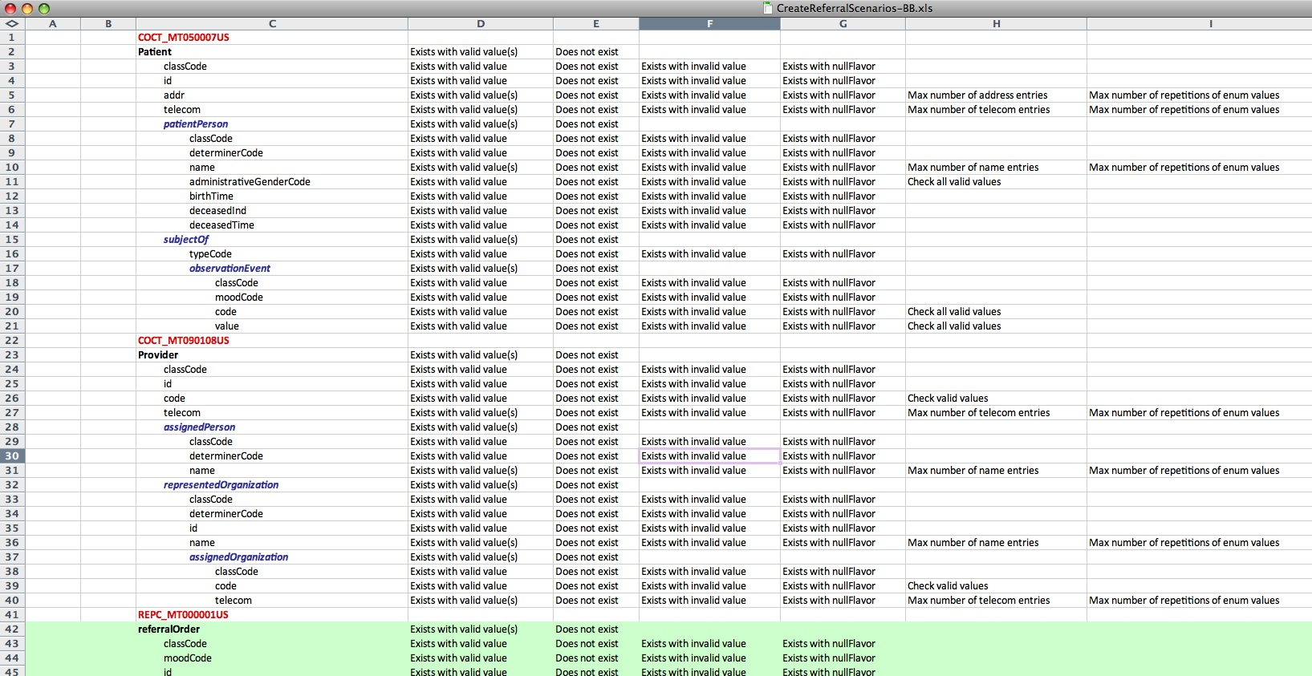

For each data attribute the following tests are identified, as applicable to the type of data:
- Attribute has a valid value
- Attribute has an invalid value
- Attribute does not exist
- Attribute has a null value
- Check all valid values
- The maximum number of attribute entries is tested
- The maximum number of repeated enum entries is tested

To aid in the creation of test cases exercising a variety of data values the following spreadsheet can be created based on searching the Architecture artifacts:

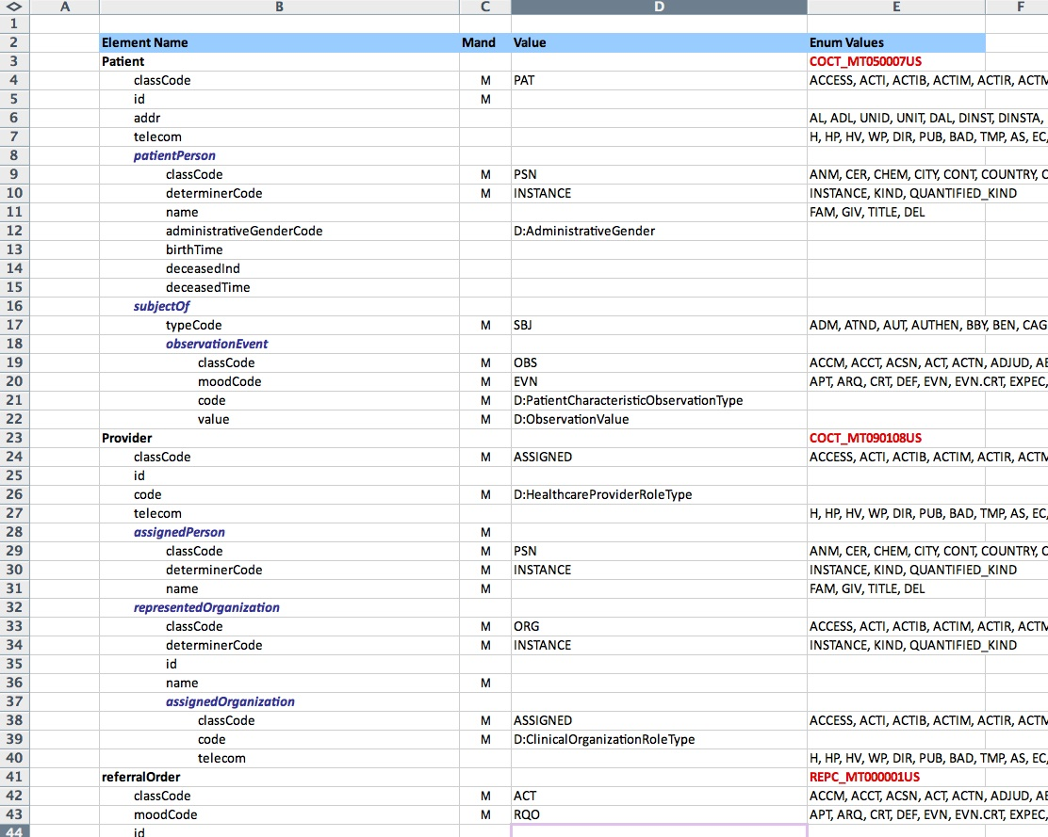

This spreadsheet lists the values for each attribute, or identifies the Terminology Worksheet tab to be consulted to find the valid values.

Once test case scenarios are created, XML test scripts are developed to be executed in SOAPUI. Examples of test case scenarios are located at:
http://spreadsheets.google.com/ccc?key=0AskpIrrhG15KdFlmNmJlUlpFSzFBYU9OTUt3UVJRZ2c&hl=en

Create Test XML Message Payloads (SoapUI Scripts)
Test scripts consisting of XML message payloads are developed based on the test scenarios as follows:
- In SOAP UI create a new project and associate the build WSDL with the project. Save it as a local project on your personal computer.
- In the “Test Properties” section of SOAP UI set the project to be a Composite Project (“true”). This saves each test case as a separate file.
- In the Project create a new “Test Suite”. Generally the team sets up one test suite per tester. For example, separate team members may test the Patient, Provider, Referral Order, and Treatment Plan parts of the createReferral service. Separate test suites would be created for each tester’s suite of tests.
- Under the Test Suite create a “Test Case” for each test to be performed. Name the Test Case by the Test Case ID (e.g. EHR-PAT-001).
- Double click the test case entry and, under the “Test Steps” tab, click the “Create a new Test Request Test Step” button. Name the test step by the Test Title given in the Test Scenarios spreadsheet.
- Copy a minimum XML message into the test step and tailor it as required to meet the test case requirements.
- Once all of the test cases are successfully created on the local computer, copy the test case files to the appropriate folder in the SVN directory and commit to the SVN repository. This will allow other members of the team to access each tester’s Test Suite.

The image below shows an example of test case EHR-RO-001 in the ReferralOrder test suite:

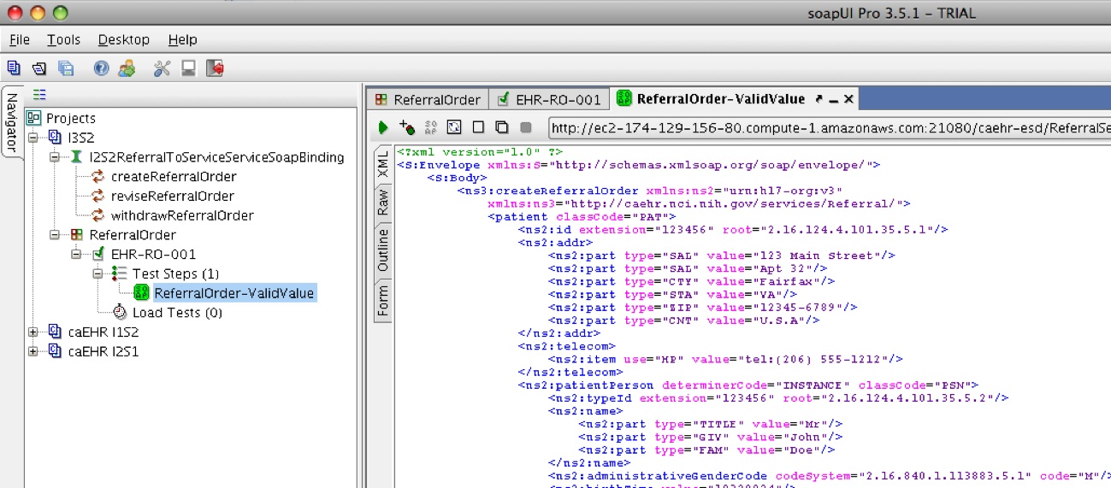

Execute Test and Validate Results

Record Test Result and document defects as needed

Automated Testing
- Developer unit tests will be created in jUnit 4.8.
- HP Quality Center (QC) will be used to plan and manage tests and test execution. Initial documentation of defects will also be facilitated by HP QC.
- SoapUI will be used as an interim test submission tool until HP Quality Center is fully configured for test execution and test automation frameworks are developed for automation execution.

Requirements Traceability
- Requirements traceability will be used throughout the analysis-design-development-testing process. QA plans to use a tool like IBM Rational DOORS to track unique identification of requirements from the analysis team through to QA verification of each requirement in the completed component.
- The development team must implement all of the requirements captured in the PIM.
- QA must show that all requirements in the PIM have been tested.

Metrics and Defect Tracking
- JIRA will be the central caBIG location for all defects. JIRA Studio is the hosted software development suite used by caBIG to support the agile development process.
- HP Quality Center (QC) will be used for test case management, which includes a defect tracking tool as well. Defects will be entered by QA into the QC defect tracker, and a synchronizer called JIRA Bridge will be used to create corresponding JIRA issues that are synchronized both ways as updates are made.
- Other Quality metrics has been developed to track and measure the Quality of the delivered artifacts and coded implementations. Please refer to Metrics Outline for caBIG for specifics.

